CS 255 System Design Document Template

This template lays out all the different sections that you need to complete for Project Two. Each section has guidance to prompt your thinking. You will need to continually reference the interview transcript as you work to make sure that you are addressing your client’s needs. There is no required length for the final document. Instead the goal is to complete each section based on what your client’s needs are. Remove this note when you are finished, and replace all bracketed text with the relevant information.

UML Diagrams

UML Use Case Diagram
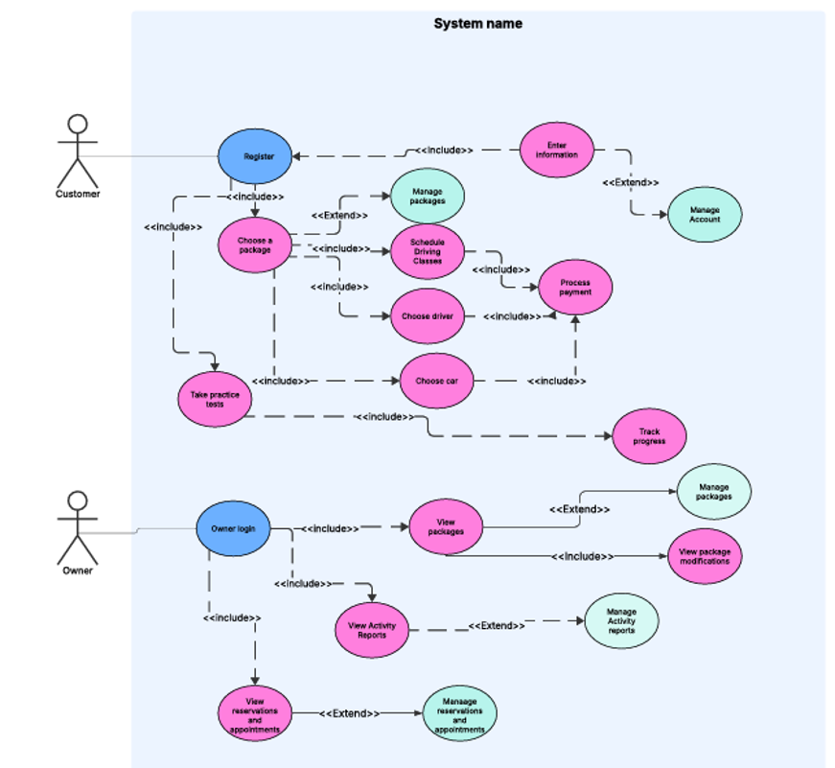

UML Activity Diagrams
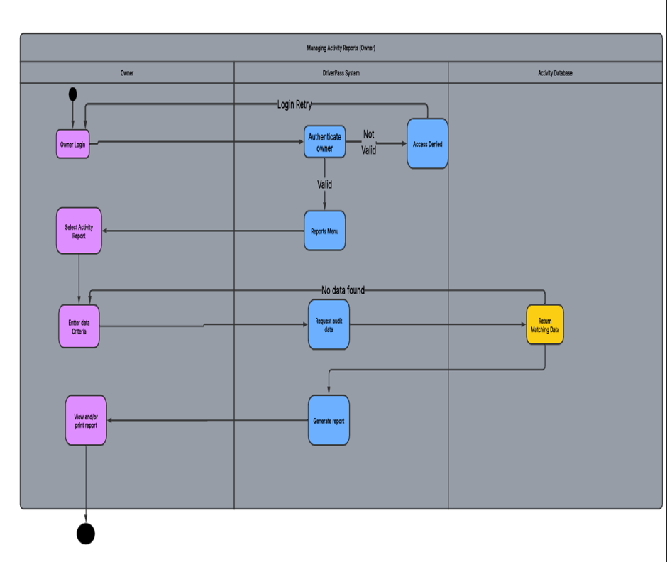

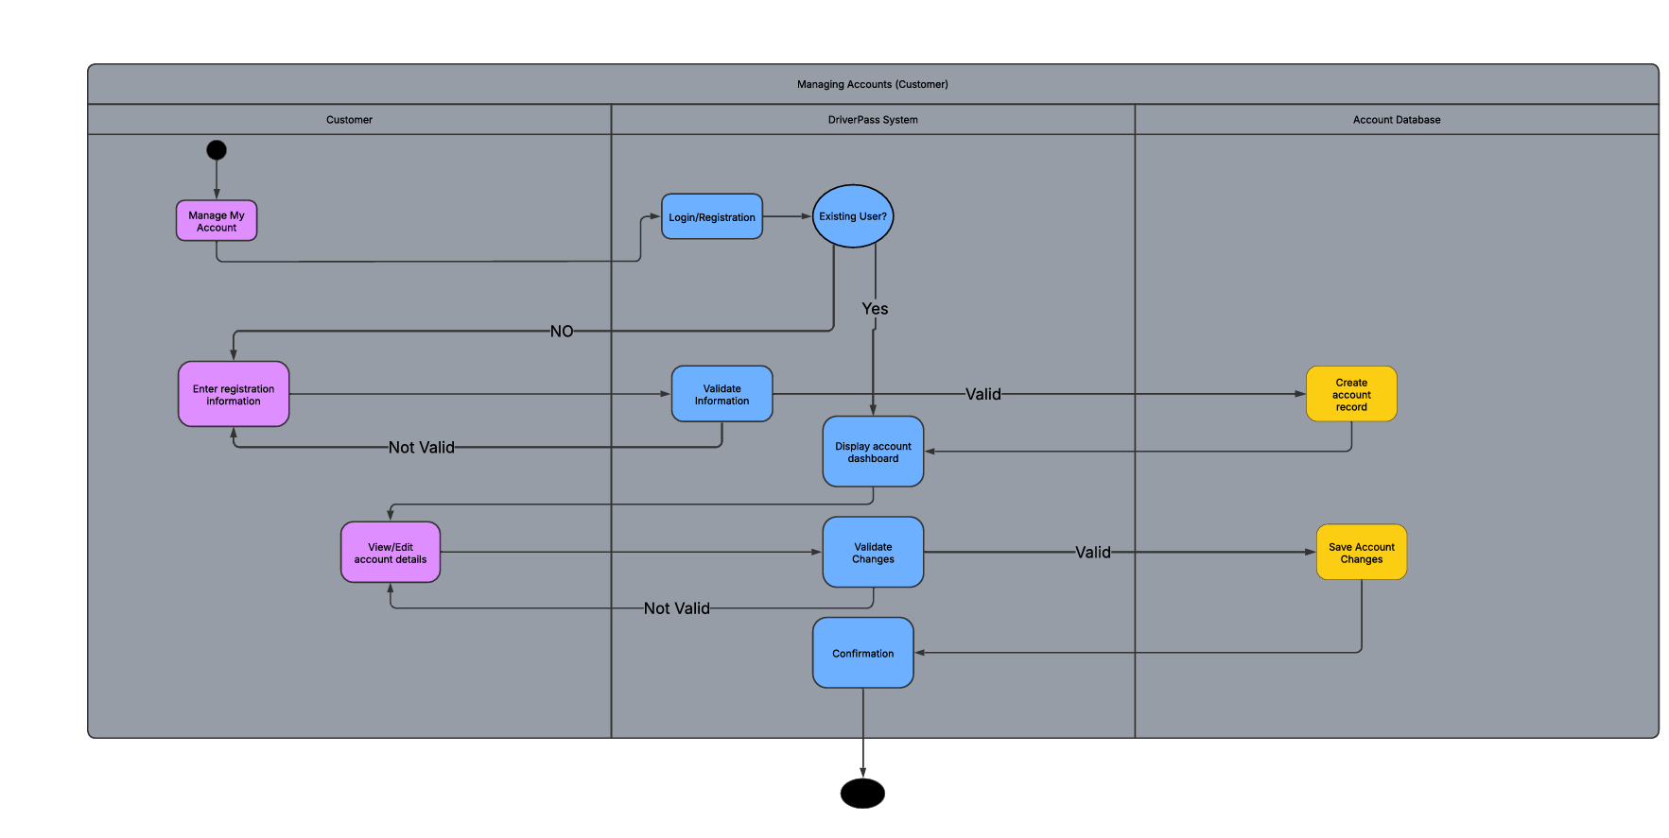

UML Sequence Diagram
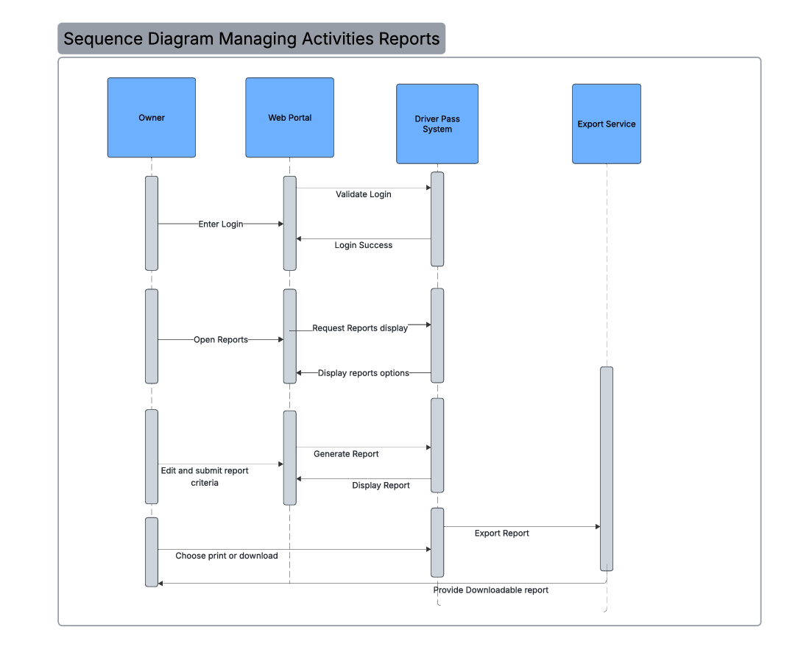

UML Class Diagram

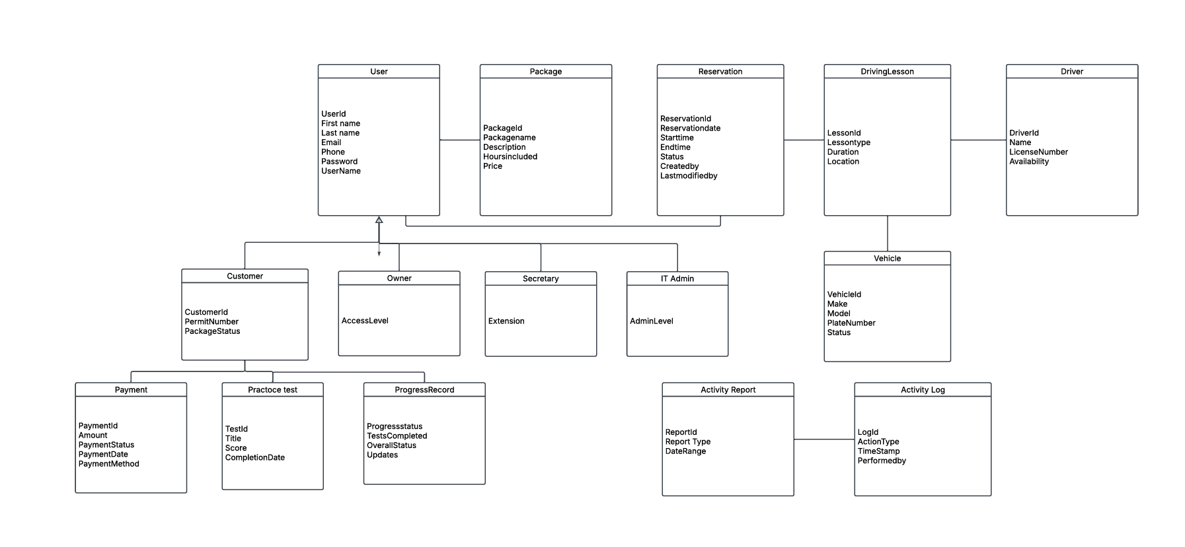

Technical Requirements
Hardware
• The DriverPass system will include cloud-hosted resources and database storage to run and manage data. Customers and employees will access the system through all devices with a modern web browser and a reliable internet connection. DriverPass business offices will also need standard workstations for the each employee tailored to their role.
Software
• The system will include a browser-based web application, a centralized database, account authentication, role-based access controls, reservation scheduling, reporting/export features, and a secure payment-processing connection. The reporting features should support downloadable content in case the owner requested offline access to reports. The system should also support continuous DMV updates or notifications so DriverPass can keep rules and policies current.
Tools
• The design should be supported with UML modeling tools such as Lucidchart for diagrams. Development should use testing tools and issue tracking to manage changes. Administrative tools should allow the IT officer to reset passwords, disable accounts, and manage permissions.
Infrastructure
• The infrastructure should include HTTPS/TLS encryption, automated backups, activity logging, and database access controls. The system should use one centralized data source for live updates to avoid redundant records being created. It will also include monitoring and recovery procedures so DriverPass can keep the system available for customers and staff.

